ELŻBIETA SKÓRSKA 20055782

From cave paintings to galleries and museums: How money created division in society’s access to culture (and how architecture and street art could heal the divide)

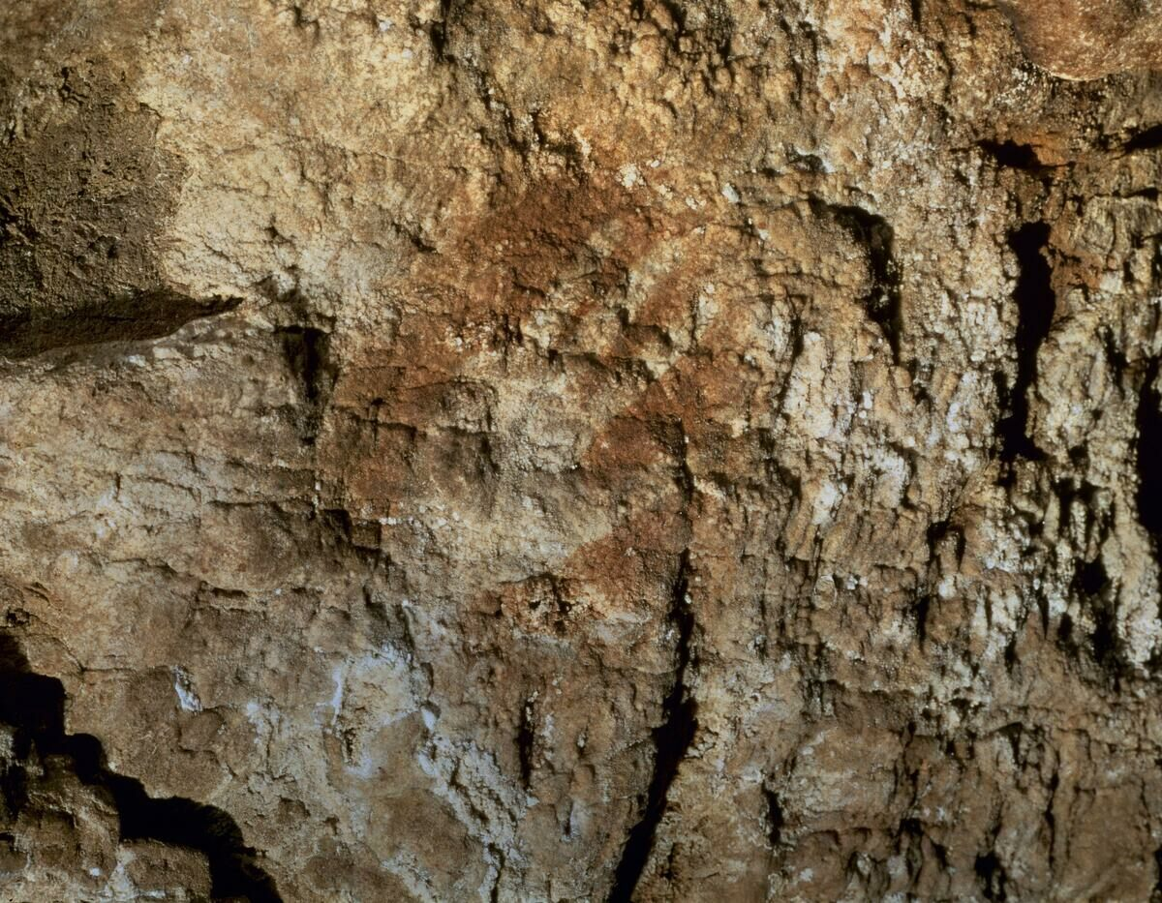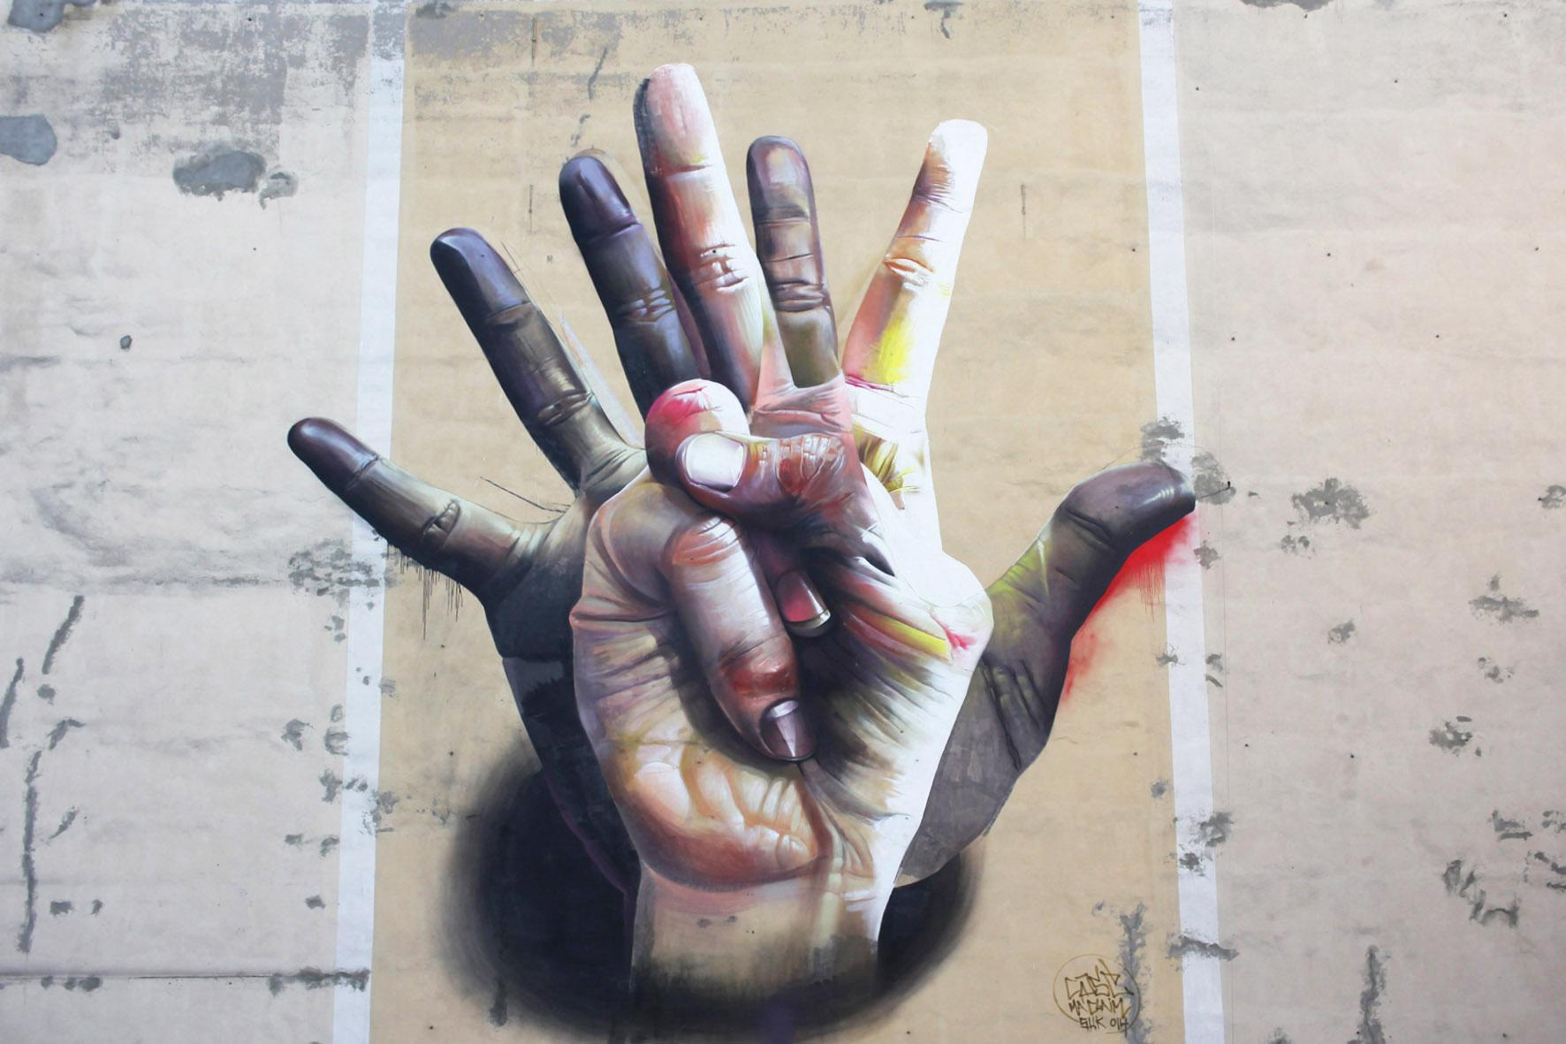

Figure 1: Cave of Maltravieso Figure 2: Case Maclaim ‘Unter der Hand’ (2014)

When a neanderthal left a red hand stencil in a Maltravieso cave around 64,000 years ago, they not only left their imprint on that stone wall, a multitude of years later, they also imprinted on us (fig.1).
This act of creativity emphasised the actuality that art is the essence of human nature.
The discovery of this earliest illustration of human artistry alters what we know about the development of art (Clottes, 2008: fourth cover) and reveals how thousands of years ago, before civilisation had even started to form, early humans already felt a need to express themselves, in a way that is not dissimilar to how we express ourselves today (fig.2).
Whereas early humans had cave walls, today we have the walls, streets and buildings of our cities to engrave, paint on, construct and express ourselves within.
This assignment will discuss how and why we shifted from art for all and everywhere to art for only some people and in certain places. It will then focus on what a city can offer in terms of accessibility to the arts and examine how street art and architecture could reclaim art for the benefit, enjoyment, and progress of all. Omnipresent and visible to everyone, they might be a gateway to art for those cut off from it by the heavy doors of galleries and museums.

Clottes (2008:12) states that ‘when humans began to draw, their skills may have developed rapidly’. It could be argued that these were not just their artistic skills. In Art and Identity: Essays on the Aesthetic Creation of Mind Tone Roald and Johannes Lang (2013) discuss how art shapes our minds and lives in a way that nothing else does, it challenges our ways of being, tests our consciousness and identity, and calls for a new social order.
Since the beginning of time, humans have not only shared an instinct for survival but also a desire to express ourselves artistically and share our creations with others. It could be argued that they chose to paint on cave walls simply for preservation. On the other hand, it could indicate an intrinsic human need to designate a place to display and revisit art. Perhaps the explanation is in the words of Brazilian artist Romero Britto who exclaims ‘Art is too important not to share' (Dybis, 2017).

Yet between then and now, art has made a journey from publicly accessible palaeolithic paintings to exclusive art and gallery spaces. More often than not, these high-priced locations are inaccessible to those from less fortunate backgrounds, those that could arguably benefit the most from free admittance to it.
Research has shown that widespread accessibility to museums is a notable factor in the development and economic advancement of urban neighbourhoods and promotes community involvement, volunteering and unity between diverse socio-economic groups (Thebaut, 2007). Americans for Arts found that young people involved in the arts exhibit 'higher academic performance, increased standardised test scores, more community service, and lower dropout rates' (ibid., 563). In the case of adults, ‘The Baltimore Art Museum found that the number of non-white visitors tripled after it eliminated its entrance fees’ (ibid., 562).
Thebaut (ibid.) considers the belief that access to museums should be a commercial service financed solely by people, not society, as an impediment to accessibility. She explains that while visiting museums undoubtedly prospers individuals, the whole country benefits from having access to museums.
All this evidence demonstrates that while we may perceive the benefits that access to the arts brings to individuals, the people in power who could bring on the change are reluctant to do the right thing, the obvious thing. In the words of Liza Minnelli 'Money makes the world go round’.

It seems like nothing can be done against the power of money. But the human is an inventive and rebellious creature, and as the last six million years have shown, we can't be stopped. We built the civilisations, along with them the cities, and the potential is endless.
With this in mind, this essay will analyse how street art and architecture can act as cultural bridges for people from less fortunate backgrounds. Additionally, it will discuss how they are radical acts of anti-establishment and anti-capitalist revolution and examine the exclusivity of museums and galleries in this context.

In Art, space and the city: public art and urban futures (1997), Malcolm Miles asserts that while public art is a diverse social means of criticism and engagement, it is not accelerated by the same intellectual viewpoints that contribute to other disciplines. He questions ‘the level of education required if an observer is to understand the work (...)' (ibid., 6). It could be argued that Miles’ observations are entirely detached from reality and in complete disregard for the intellect and artistic sensitivity of 'common' people, as contended by Berkovitz:

‘The public knows far more than it is given credit for. Put people in front of something with real content and they will know it. Put some intellectuals in front of a big nothing and they will be convinced that here is something sublime…The irony is that the public often knows better than the experts’ (Globe & Mail, 1993).

Fundamentally Miles sees public art as a peripheral field within the arts of 'little appeal to curators, dealers and critics' (1997:1). When there is no generation of prestige and earnings coupled with the artwork on display, Miles seems to disregard it, entirely overlooking the non-profit value that every piece of art holds within.

One argument is that if galleries and museums were genuinely for the public, they would be publicly accessible, free from any admission. Some argue that charges exist because the elite wants to govern the art world, consequently creating a division between ‘’us’’ and “them’’. This is certainly a view supported by Cockcroft et al. (1977: 236) who in Toward A People’s Art explains ‘In any society characterised by class divisions and class conflict, there is always a struggle for control of art (not only visual art but of all cultural expression)’.
The policy discussion on museum charges has a lengthy history, is extensive and incorporates a combination of 'political ideology, institutional and political pragmatism, cultural, educational, leisure and recreational issues, professional cultures and social policy perspectives' (Stephen Bailey et al., 1998: 2).
In Charging for Admission to Museums and Galleries: Arguments and Evidence, Stephen Bailey et al. (ibid.) present arguments both for and against charging for admittance to museums. The claims in favour are that if other cultural and leisure activities require compensation, so too should museums. Furthermore, charges are vital financially, they lower stress on the taxpayer in terms of museum funding, pay for the quality of service and provide necessary extra income. The arguments against are that they reduce the number of visitors (in particular based on their social composition or their propensity), conflict with access goals, and are against the cultural and educational missions of museums. Additionally, Bailey et al. point out that shop sales and catering revenues decline subsequently, coupled with a negative impact on spending in the local economy.
This research demonstrates how complex this issue is. There are clearly valid points to be made on each side. From these debates, it is apparent that the discussion is back at the dilemma of money versus the good of all people. Taking accessibility into consideration, I further my point with the flawless words of Dr Neil MacGregor, former Director of the National Gallery:

‘Our museums were not set up to earn money or to pay taxes, but for education and lifelong learning…Their purpose is to improve the quality of life for all. Free museums are important in the way that free health care is...Museums are more than a way of finding out about history or art. They provide peace and contemplation, and stimulate us with the discovery of other worlds and ways of thinking. Essential to our education and our spiritual health, they have a therapeutic as well as didactic role. They are no more a luxury in modern life than literacy’ (Stephen Bailey et al., 1998: 7).

Another matter that requires analysis is based on socioeconomic and racial grounds. In the article Introduction to special issue: artist development: class, diversity and exclusion, McKinney points out that stimulus to creativity starts with arts education by referring to a briefing report published in 2019 by the Cultural Learning Alliance and Paul Hamlyn Foundation (2020). In the report, the writers argue that ‘arts education is a social justice issue’ (ibid., 235) and claim that the decline of arts provision in state schools will further worsen the imbalance of prospects between state and privately educated children (ibid.). Furthermore, they warn that:

‘[w]ithout educational intervention we are in danger of allowing a two-tier system in which the most advantaged in social and economic terms are also the most advantaged in benefitting economically, socially and personally from the full range of cultural and creative experiences’ (ibid., 235)

Therefore it is evident that initiation to the arts in the early years of education is a critical moment for those from lower socioeconomic backgrounds. Whether early or at any point in life, connection to the arts can help individuals to realise their potential and the possibility of making art a profession.

Art and money intersect in many ways, as Lovell (2009) aptly observed '(...) money is everywhere art is, implicated in the conditions of its production, reception, and survival' (ibid., 4). Lovell warns us of this dangerous space which is ‘mundane’ and ‘soiled’ and is opposed to ‘those points of intersection between art and creativity, originality, genius, and ideas’ (ibid.).
While the inclusion of money in the arts is inevitable (after all artists need to eat, pay bills, preferably live from their art and feel successful for it), it can also be a detrimental influence behind creativity and the creation itself.
Perhaps this is why people have taken art to the streets, where they can express themselves freely both in methods and subjects of their artistic manifestation. Independently from what money dictates, they have rebelled, constructed and reclaimed, creating opposition to elitist galleries, touching on issues outside of the capitalist narrative.

Street art talks about social inequality, failing infrastructure and religious proselytising. It critiques advertising, politics, establishment and elitism, and employs subcultures, popular culture and mass media as fuel for artistic practice (Alonzo and Sarinman, 2010).
It has been argued that artists who create on the street consciously direct physically accessible artwork to a wider audience, who may not visit museums or galleries (ibid.). Through their actions, they simultaneously start a conversation, not just about accessibility, but also about what art is and who gets to decide what art is: 'Addressing those outside the art world is a tricky manoeuvre: it poses questions about commercial art versus fine art, populist versus elitist. The conflict, as it were, is heating up as this new generation uses street to stake their claim in the arts establishment'. (ibid., 10)
In Alonzo and Sarinman’s analysis, one thing is clear, this is a revolution and the artists are ready for the fight. Perhaps they are heading into battle with Britto’s slogan of ‘Art is too important not to share’ on their banners.

Another creative and life-changing rebellion that holds the potential to reach us all is architecture. The art of architecture has a profound and diverse purpose that influences those around it, and contrary to some other crafts, it has the advantage of being non-discriminating, anyone can appreciate it. Moreover, it can benefit us simultaneously aesthetically and functionally (as a habitat, workspace etc.), which gives an additional dimension to its creation and what it can offer.
The significance of architecture has been much discussed through a range of analyses. For Gray Read, architecture is a performing art that acts depending on the individuals, the location, and their interpretations at the present time. They describe how architecture is both stage and actor in the endless theatre of life and define buildings as constructed things that perform socially with people in place (Feuerstein and Read, 2013). Edward and Mildred Reed Hall assert that our surroundings are nowhere near being passive. For them, the environment starts an interaction with humans and portrays edifices not just as objects but as “statements’’ - engaged agents in the human condition (Hall and Hall, 1975).

Similarly to street art, architecture functions across numerous issues - political, social, cultural, theatrical, technological, medicinal, artistic, material, poetic, etc., and its activities have results that can be monitored and calculated (ibid.)
All this evidence demonstrates that the potential of architecture is limitless, and it impacts everyone, hence making it a perfect ‘'weapon’' in the battle of arts for everyone. As one of the most solid links to culture that each individual, no matter the background, is inherently exposed to, it enriches the lives of us all just by the very nature of its existence.

This essay has considered the issue of art accessibility and inclusivity that has been created by a profit led business model that affects those from less privileged socioeconomic backgrounds and the role that architecture and street art play in balancing and remedying the issue for everyone in the society.
The unquestionable and essential need for humans to express themselves through art and correspondingly, as a result of access to it, to have the opportunity to grow as a thinking, feeling homo sapiens, the “wise man”, is paramount in advancing individual lives and society as a whole.
As discussed throughout the essay, the alternative subjects that street art speaks to are a healthy counterbalance to art in museums. More importantly, street art reaches, touches, and inspires people with no exceptions. Similarly, the ubiquitous nature of architecture communicates, engages, and participates in everyone's life.
This analysis allows the conclusion that the path of inclusiveness should be a priority, moral, democratic, compassionate act, and perhaps if our governments fail us in providing enough funding for this to happen, we ought to take things in our hands and into the streets.

Bibliography

Alonzo, P; Sarinman, L. (2010) Viva La Revolución: A Dialogue with the Urban Landscape. ‎California: Gingko Press.

Bailey, S.; Falconer, P; Foley, M; McPherson, G; Graham, M. (1997) ‘Charging for admission to museums and galleries: arguments and evidence’, Museum Management and Curatorship, Vol.(16.), pp 355-369

Barker, P. (1977) Arts in Society. London: Fontana Communications Series.

Berkovitz, M. (1993) ‘Portrait of the artist as an elitist in the picture’, Globe & Mail. [Online] 8 September, 1993. [Accessed on 01/12/21] https://go-gale-com.mmu.idm.oclc.org/ps/i.do?p=AONE&u=mmucal5&id=GALE|A163878460&v=2.1&it=r&sid=oclc

Clottes, J. (2008) Cave art. London: Phaidon Press.

Cockcroft, E; Weber, J; Cockcroft, J. (1977) Toward A People’s Art. New York: Dutton & CO.,INC
Dybis, K. (2017) ‘Art is too important not to share’ says Brazilian born sculptor/painter’. Corp. [Online] 13 July, 2017. [Accessed on 30/11/21] https://www.corpmagazine.com/features/art-is-too-important-not-to-share-says-brazilian-born-sculptorpainter/

Feuerstein, M; Read, G. (2013) Architecture As a Performing Art. [ProQuest Ebook Central] Taylor & Francis Group.

Hall, M; Hall, E. (1975) The fourth dimension in architecture : the impact of building on behavior. Santa Fe: Sunstone Press.

Harvey, D. (2012). Rebel Cities : From the Right to the City to the Urban Revolution. [ProQuest Ebook Central] Verso.

Keeble, B. (1998) Art for Whom and for What?. Ipswich: Golgonooza Press.

Lovell, M. (2009) ‘Money’. American Art. [Online] Spring 2009. [Accessed on 30/11/21] https://web-s-ebscohost-com.mmu.idm.oclc.org/ehost/detail/detail?vid=1&sid=9c38f965-88d6-4ee9-900d-75202f560fbd%40redis&bdata=JnNpdGU9ZWhvc3QtbGl2ZQ%3d%3d#db=asu&AN=505410888

McKinney, J; Tomlin, L. (2020) ‘Introduction to special issue: artist development: class, diversity and exclusion’, Studies in Theatre and Performance, Vol.(40), pp. 231-241. https://doi.org/10.1080/14682761.2020.1807215

Miles, M. (1997) Art, space and the city : public art and urban futures. London: Routledge.

Miles, M. (2004). Urban Avant-Gardes : Art, Architecture and Change. [ProQuest Ebook Central] Taylor & Francis Group.

Roald, T; Lang, J. (2013) Art and Identity : Essays on the Aesthetic Creation of Mind. Amsterdam: Editions Rodopi.
Rosengren, M. (2012) On Cave Art, Perception and Knowledge. New York: Palgrave Macmillan.
Thebaut, N. (2007) ‘Improving Accessibility to Art Museums’. Policy Studies Journal, Vol. 35 (No.3), pp. 562-563

References for images

Figure 1: Cave of Maltravieso. [Online] [Accessed on 10/11/20]
https://www.atlasobscura.com/places/cave-of-maltravieso

Figure 2: Case Maclaim ‘Unter der Hand’ (2014). [Online] [Accessed on 10/11/20]
https://withberlinlove.com/2015/12/15/case-maclaim-unter-der-hand-mural/

